Voice Mail Administration

System Administration

Mailbox 900 provides for basic system administration such as changing the time and resetting a password.

To access mailbox 900:

Call the voice mail-- You can usually just press your message key or from in the office this is usually intercom 300 (NEC IPK), 3000 (NEC IPK II), 250 (Toshiba CIX-40 or CTX-28), or 850 (Toshiba CIX or CTX 100 or 670)

If you are asked for your security code, press * to cancel auto-login.

If prompted for your User ID enter 900. If not prompted for User ID press 7, then enter 900 once prompted for User ID. When calling from outside the office, you must enter 7 at the main greeting.

The security code is also 900.

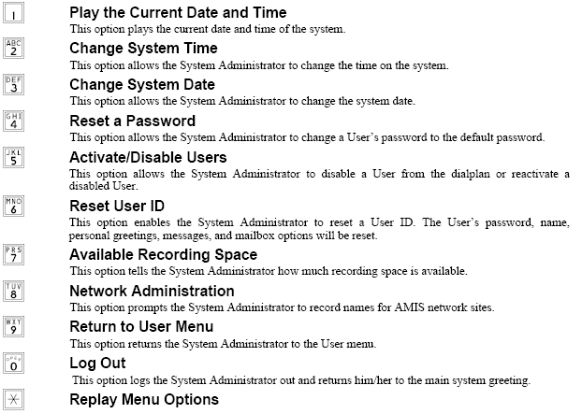

System Greetings

Mailbox 980 is where all system greetings are stored.

To access mailbox 980:

Call the voice mail-- You can usually just press your message key or from in the office this is usually intercom 300 (NEC IPK), 3000 (NEC IPK II), 250 (Toshiba CIX-40 or CTX-28), or 850 (Toshiba CIX or CTX 100 or 670)

If you are asked for your security code, press * to cancel auto-login.

If prompted for your User ID enter 980. If not prompted for User ID press 7, then enter 980 once prompted for User ID. When calling from outside the office, you must enter 7 at the main greeting.

The security code is also 980.

Mailbox 980 is set up to go into Call Management mode immediately upon login.

You will hear “to play current personal greeting press one, select next personal greeting press four” etc.

Using this menu you can choose which greeting you want to change. Each greeting is designated as follows:

1. Day / Open Introduction (just “Thank you for calling ABC Company”)
2. Day / Open Instructions (the rest of your greeting)
3. Night / Closed Introduction
4. Night / Closed Instructions
5. Holiday Introduction
6. Holiday Instructions

Greetings 7 and 8 are the ones actually playing at the moment. You can over record them to put up a temporary message, but that message will be removed at the next scheduled event such as changing from your day message to your night message. Normally your voice mail automatically changes from the day greeting to the night greeting at 5 or 6 pm and back to day at 8 or 9 am. Anything you record in greetings 7 or 8 will only play until the next time the system changes Day/Night. To put in a temporary message that will last longer use greetings 5 and 6 for Holiday.

Note: When changing any greeting (other then 7 or 8) you must follow the instructions for mailbox 910 below to load the messages manually in to memory. If you don’t, the message will load the next time the scheduler changes. Holiday message must be loaded and unloaded manually in mailbox 910. See the next page for those instructions.

Changing Day / Night / Holiday Mode---910

910 works differently from any other mailbox. You do not log into mailbox 910, you simply press 910 at the main system greeting. You do not press 7, 910, just 910.

Call the voice mail-- You can usually just press your message key or from in the office this is usually intercom 300 (NEC IPK), 3000 (NEC IPK II), 250 (Toshiba CIX-40 or CTX-28), or 850 (Toshiba CIX or CTX 100 or 670)

From outside, simply call your phone number and wait for the auto attendant to pick up or ask the receptionist to transfer you to voice mail.

If you are asked for your security code, press * to cancel auto-login. If you are then prompted to enter user ID, press * again. This should put you at the company main greeting. Dial 910.

You will hear:

To set open /closed / holiday mode press 1
To set business hours press 2 (Please call Teleco if you wish to change your open/closed schedule)

Select option 1. You will hear:

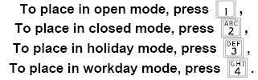

Open mode loads greetings 1 and 2 from mailbox 980. Closed mode loads greetings 3 and 4. Holiday mode loads greetings 5 and 6. Holiday mode will keep playing the Holiday message, regardless of the scheduler, until you select Workday mode. When you select Workday mode, the voice mail will automatically play either the open or closed message based on the time of day.

